SCRS/2009/180

THE FIRST CERTIFICATION OF BLUEFIN TUNA ISSUED IN THE MEDITERRANEAN SEA: THE ECOCREST© LABEL PROVIDED FOR THE 2009 PRODUCTIONS OF TWO TRADIONAL TUNA TRAPS IN SARDINIA.

Antonio Di Natale – Piero Addis

SUMMARY

The difficult situation of the recent management of the Eastern Atlantic Bluefin Tuna (Thunnus thynnus) indirectly needs initiatives able to distinguish the best practices and the transparency of the fishing activities.
The traditional tuna traps, with their long history, are important either for a sustainable production point of view or for cultural reasons.
For the very first time, in 2009 it was possible to release the ECOCREST© certification to a Mediterranean fishery and this was possible with two ancient tuna traps in Sardinia (Italy): the tuna trap of Isola Piana and the tuna trap of Portoscuso, owned by the same company.
The certification and the use of the ECOCREST© label will allow the consumers to distinguish this product on the market and to have a serious guaranty about the respect of the fishery, environmental and labour rules and the ethics of the production.

KEYWORDS
Bluefin tuna; Conservation; Catch composition; Traditional fishery; Tuna trap; Mediterranean Sea; Eco-Label.

- Introduction

The tuna trap fishery is a one of the most ancient fishing activity in the world, possibly the oldest among the industrial ones. This activity is well documented in many scientific papers, with a particular attention to the tuna traps in Sardinia (Addis et al., 1997, 1998, 2006; Angitzi, 1901; Belloc, 1961; Cetti, 1777; Dean et all., 2003; De Cristoforo, 1970; Di Natale, 1988, 1989; Doumenge, 1998; Mariotti, 2003; Mondardini, 1999; Parona, 1919; Pavesi, 1889; Scaccini, 1965; Scaccini and Biancalona, 1959; Secchi, 1918; Sella, 1929). The tuna traps were very numerous all around the Mediterranean coasts till the first part of the XX century (Doumenge, 1998; Parona, 1919; Pavesi, 1889; Sarà, 1983), but they decreased to less than twenty in the last decade.
Independently from the general increasing effort on bluefin tuna (Thunnus thynnus, Linnaeus, 1758), then the tuna traps decreased their impact on the stock. Their catches can be easily checked, because the fishing operations, ending with the traditional “mattanza”, are not so numerous in the short fishing season (May to the beginning of June).
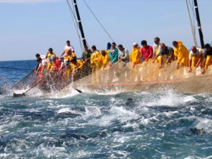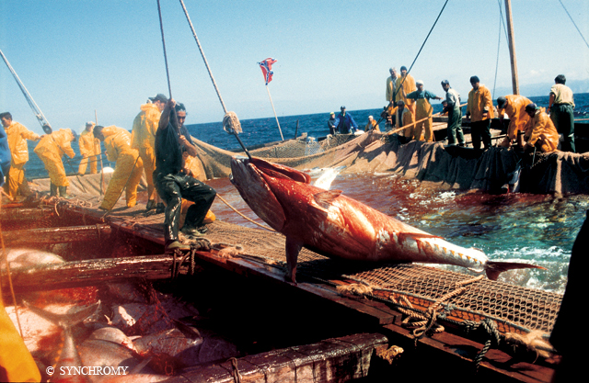
Figure 1 (left) – The final haul of the net in the “death chamber” in the tuna trap of Isola Piana.
Figure 2 (right) – The traditional “mattanza”, the rapid killing of tunas, in the trap of Portoscuso.
The bluefin tunas which enter into the trap are usually adult tunas, just before or after the spawning and sometimes small tunas, at the first maturity, are found together with medium and large size specimens. Juveniles can be caught only by a different type of tuna trap, the “tonnarella”, having nets smaller than the traditional ones and usually set in different coastal areas, where these young size classes usually concentrate for feeding reason.
The tuna trap in Portoscuso initiated its activity in 1497 (and then restarted again, after some unknown times, in 1587), while the tuna trap in Isola Piana – Carloforte began in 1698. The traps located in this area in SW Sardinia had several troubles in the past, caused by the negative impact of anthropic activities and sludge coming from coastal mines, which heavily affected the presence of tuna and then the catches (Addis et al., 2008a, 2008b; Di Gregorio and Massoli-Novelli, 1992; Grassi, 1913; Mazzarelli, 1917).
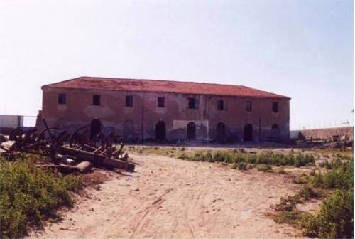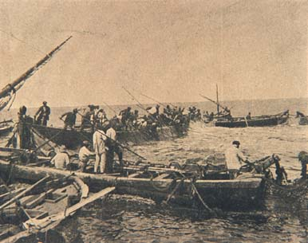
Figure 3 (left) – The ancient building of the tuna factory (tonnara) in the Isle of San Pietro.
Figure 4 (right) – An ancient picture of a “mattanza” in a tuna trap in Carloforte.
2. The ECOCREST© certification

The ECOCREST© certification is officially released by the Fondazione Acquario di Genova Onlus, a non-profit Foundation, having several public administrations among its members and it is under the legal control of the Ligurian Regional Government. Among the Board members there are also marine scientists and there is a high reputed international Scientific Committee. The ECOCREST© label was officially registered in 2006 and the first certification was released in Australia in 2007.

Figure 5 – The ECOCREST© label, distinguishing all aquatic products who had obtained the certification.
The ECOCREST© certification procedure was developed in 2006 to identify all the aquatic products having a very high ecological and ethic level. The certification is also supported by the International Labour Organisation (ILO) of the UN. It is based on independent inspections, having the duty to check the full respect of a sustainable exploitation of the resource, the FAO code of conduct, the local environmental, fishery, labour and health rules and the guidelines of the ILO, including the protection of children. Further requirements are also included, like the provision to decrease and reuse the discards or the impact on the environment. In developing countries, fair trade agreements, transfer of know-how or the involvement of the local inhabitants in the process are also necessary. In the specific case of the bluefin tuna (Thunnus thynnus, L.), it is also mandatory the full respect of the ICCAT rules and the following EC and Italian regulations.
The royalties coming from the certification go back to the Nature, and they are fully used to carry out research and conservation projects or educational and awareness activities. The philosophy of the entire system is to transparently ensure a traceability of the product and an added value to the distribution chain till the consumer. Products having the certification are considered top level ones.

3. The certification of the tuna trap production in Isola Piana and Porto Scuso

The ECOCREST© certification was initially requested by the company “Carloforte Tonnare PIAM s.r.l.”, owner of the two ancient tuna traps in Isola Piana and Portoscuso (SW Sardinia, Italy) in 2008, but it was necessary to deeply analyse the situation before establishing the preliminary feasibility of the procedure. As a matter of fact, the request was carefully examined, because the Bluefin tuna (Thunnus thynnus L.), according to the ICCAT, is overexploited (ICCAT-SCRS, 2008) and there are several serious management problems (Di Natale, 2008). Due to the fact that overexploitation was never attributed to any tuna trap and that this gear is considered selective and with a high cultural relevance, it was decided to begin the certification procedure.
In 2009 it was decided to carry out the independent inspection, that were conducted by the scientists of the Department of Animal Biology and Ecology of the University of Cagliari and by the military staff of the Capitaneria di Porto of Cagliari or by the staff of its local offices. All the fishing operations were directly monitored, checking the respect of the national quota and the size of each specimen. All the few bluefin tuna smaller than 30 kg were released alive at sea. A total of 115 tons of bluefin tunas were caught by the two traps and landed in the tuna factory in Carloforte. The size frequency of a subset of the catches is shown on figure 6.
Figure 6 – Size distribution of a sub-sample of bluefin tuna (Thunnus thynnus) caught by the tuna trap of Isola Piana during the 2009 fishing season. All specimens below 30 kg were released alive at sea.
The inspection reports, including those related to all permits, were transmitted by the University of Cagliari to the Foundation for the evaluation and for keeping them in the chain of custody (CoC).
The company has also a plan to better reuse the discards and, since 2009, the electric power necessary for the factory is provided by many solar panels, strongly reducing its carbon footprint.
After a further check with the Ministry of Agriculture, Food and Forestry Policies, Direction General for Maritime Fishery and Aquaculture, who has the responsibility to control the respect of the quota system, the ECOCREST© certification was finally released to “Carloforte Tonnare PIAM s.r.l.” on 13 August 2009.
The certification can be used for the tuna meat (fresh and canned) and all the tuna salty products (meat and gonads) directly sold by Carloforte Tonnare PIAM s.r.l. and it must be evident on cans and packaging.
This represents the first certification of an aquatic product in the Mediterranean Sea and, at the same time, the first certification of bluefin tuna in the Mediterranean Sea, a step towards a much more sustainable and responsible exploitation of this important and iconic species.

4. Bibliography
Addis P., Locci I., Cau A., 2008 – Anthropogenic impacts on Bluefin tuna (Thunnus thynnus) trap fishery of Sardinia (Western Mediterranean). ICCAT/SCRS Coll. Vol. Sci. Pap., 63: 174-185.
Addis P., Campisi S., Cuccu D., Follesa M.C., Murenu M., Sabatini A., Secci E., Cau A., 1998 - La pesca del tonno, Thunnus thynnus (L.) in Sardegna: indagine sull'attività' delle tonnare dal 1991 al 1998. Biologia Marina Mediterranea, , ISSN: 1123-4245, vol. 5(3): 252-257.
Addis P., Cau A, Davini M.A, Secci E, Scibaldi G., 1997 - Collection of tuna data catches by trap-nets in Sardinia: historical (1825-1980) and recent catches (1992-1995). ICCAT-SCRS Coll. Vol. Sci. Pap., , ISSN: 1021-5212, vol. XLVI(2): 132-139.
Addis P., Dean J.M., Pesci P., Locci I., Cannas R., Corrias S., Cau A., 2008 - Effects of local scale perturbations in the Atlantic bluefin tuna (Thunnus thynnus L.) trap fishery of Sardinia (W. Mediterranean). Fisheries Research, , ISSN: 0165-7836, vol. 92(2-3); p. 242-254.
Addis P., Dean J.M., Sabatini A., Cuccu D., Cau A., 2006 - Catture di Thunnus thynnus nelle tonnare della Sardegna meridionale nel periodo 1991-2004. Biologia Marina Mediterranea, ISSN: 1123-4245, vol. 13(1); 197-201.
Angotzi F., 1901 – L’industria delle Tonnare in Sardegna. Bologna.
Belloc G., 1961 – Inventaire des madragues méditerranéennes. FAO Tech. Pap. Gen. Fish. Coun. Medit., 6: 345-361.
Cetti F., 1777 – Storia naturale di Sardegna. III. Anfibi e Pesci. Tip. Giuseppe Piattoli, Cagliari: 1-208.
Dean J.M., Addis P., Cau A., 2003 – Sustainable fishing in the Mediterranean for Bluefin tuna: a case study of ancestral fishing technologies and contemporary practices. Workshop on farming, Management and conservation of bluefin Tuna, 2003, Istanbul: 102-117.
De Cristoforo S., 1970 – Le Tonnare Italiane. Ministero della Marina Mercantile.
Di Gregorio, F., Massoli-Novelli, R. 1992. Geological impact of some tailings dams in Sardinia, Italy. Environ. Geol. 19: 147-153.
Di Natale A, 1988 - Miti e tradizioni fra Uomo e Pesci In: Mare Nostrum, Rainero Ed., Firenze: 61-85.
Di Natale A, 1999 - La ricerca sulla pesca: I Grandi Pelagici. In. Le Ricerche sulla Pesca e sull'Acquacoltura nell'Ambito della Legge 41/82. Parte 4: Relazioni. M.P.A., Roma, 1999; Biol. Mar. Medit., 7(4): 46-58.
Di Natale A, 2008 – Il tonno: una gestione incerta e problematica. In: La Tonnara tra memoria e futuro. Favignana, 1 Giugno 2007: 8-12.
Doumenge F. 1998 - L’histoire des pêches thonières. ICCAT/SCRS Col. Vol. Sci. Pap. 50: 753–802.
ICCAT, 2008 – Report of the Standing Committe on Research and Statistics. Madrid, October 2008: 1-241.
Grassi, B. 1913 - Conflitto tra le tonnare Porto Paglia e Portoscuso contro la Società Anonima Malfidano. Ed. Corsi e Ciarlo, Genova.
Mariotti L., 2003 – Il Tonno. Le Tonnare che parlano Genovese. Feguagiskia Studios Ed., Genova: 1-159.
Mazzarelli, G., 1917 - Conflitto fra tonnare e miniere in Sardegna. Rivista di pesca e Idrobiologia, Anno XI
Mondardini G., 1999 – La Tonnara nella cultura marinara. In: Civiltà del Mare. Ed. ICIMAR, Olbia, X(2).
Parona C., 1919 – Il Tonno e la sua pesca. R. Comit. Talass. Ital., Venezia, Mem. LXVIII: 1-259.
Pavesi P., 1889 – L’industria del Tonno. Relazione alla Commissione Reale per le Tonnare. Min. Agric. Indust. Comm., Roma, Tip. Eredi Botta: 1-254.
Sarà R., 1983 – Tonni e Tonnare. Libera Università di Trapani Ed., Trapani: 1-128.
Scaccini A., 1965 – Biologia e pesca dei tonni dei mari italiani. Mem. Min. Mar. Merc., 12: 1-100.
Scaccini A., Biancalana T., 1959 – Les methodes de peche au thon en Italie et la pêche pelagique au filet tournant. FAO Proc. Gen. Fish. Comm. Médit., 5: 465-473.
Sechi V., 1918 – Tonnare e mattanze Sarde. Touring Club Ital., Maggio 1918: 101-106.
Sella M., 1929 – Migrazioni ed habitat del tonno (Thunnus thynnus L.) studiati col metodo degli ami, con osservazioni sull’accrescimento, sul regime delle tonnare, ecc. Mem. R.Com.Talass.Ital., 7: 24.

Fondazione Acquario di Genova Onlus – Area Porto Antico – Ponte Spinola – 16128 Genova - Italy
Department of Animal Ecology and Ecology – University of Cagliari – Viale Poetto 1 – 09126 Cagliari – Italy
Ecocrest label was previously released to other high level aquatic productions in Australia and in Europe, while procedures are closed o be finalised in India and Madagascar (www.ecocrest.org ).

